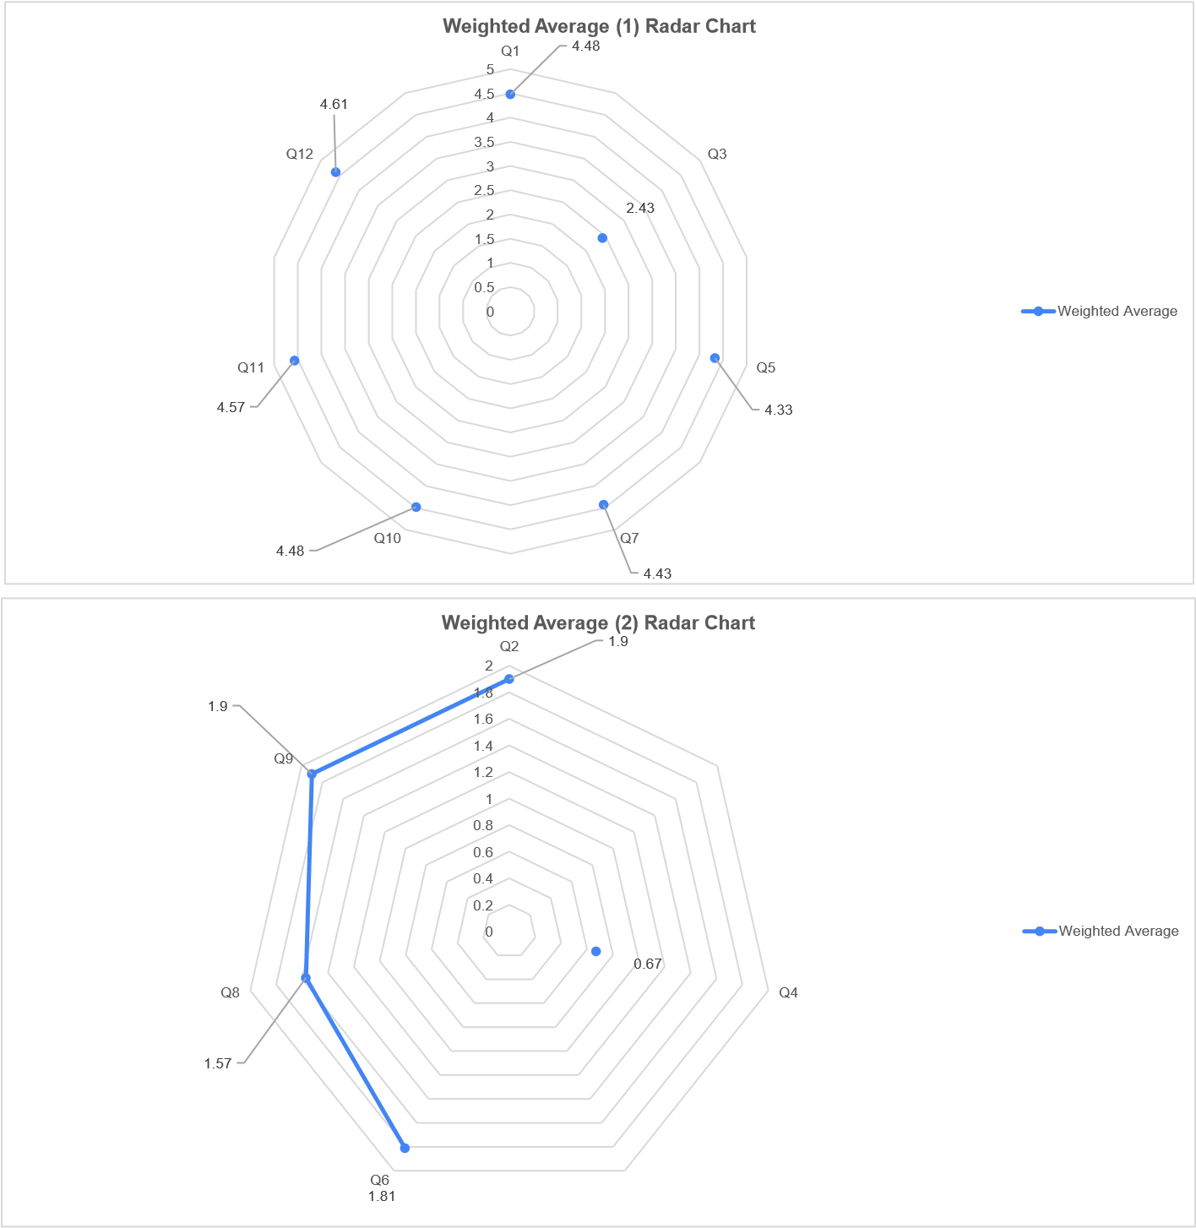

After finding the weighted average from the table here we made this radar chart from those table data. At first select all data from the table. Then by pressing on the **“Radar chart”** from the Excel software we generate the radar chart. After adding the data set name from the table we generate this Radar chart .